4.27: a)

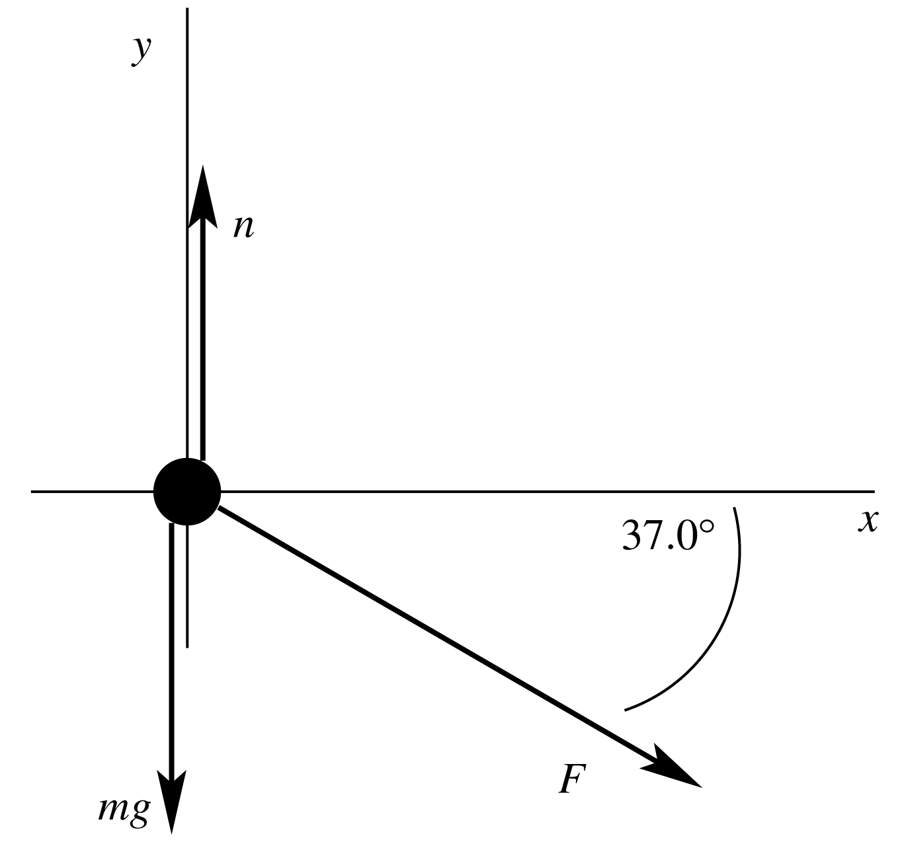

b) For the chair, 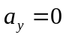 so 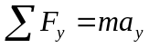 gives
